Olympus Tech 2.0

Task 3: Astral Imagination

Prompt-

Four separate images are made using microsoft copilot for better accuracy of preferred description, and chatgpt was used to merge them-

**Part 1**:Silhouette of a human hand bouncing a ball with a background :Generate a hyper realistic image of an abyssal explosion in the middle of an angelic celestial nursery. The galaxy, a colorful curtain of deep purple, blood-red, and sea-blue hues

**Part 2**: Show an aesthetic image of magnetopause phenomenon of neutron stars

**Part 3**:Silhouette of a man, inside his body there are pieces of the letter N. Background of this is a slightly depressing stellar background, as the human resembles sin.

**Part 4**: A cosmic graveyard with the letter S in it, and pieces of it breaking away

Description :

This AI generated art piece explains humanity’s likely trajectory through space and physics.

But first:

Aren’t you interested to know where humans stand, in the present state of the universe? From the larger picture?

What created the universe? How would you describe the creator?

This theory and subsequent art piece is one of the possibilities that we came up with!

The main character here is a human. This we resemble as the silhouette of a man, in a bland stellar background, as it is filled with sin and regret. The silhouette contains the letter N on its body, this is basically the north pole. It helps to show how and where the human is diverted to.

This human silhouette occupies the third part of the image.

(The image is divided into four parts.)

Now notice the last part(part 4). This resembles a cosmic graveyard. With the outcomes that human tendencies are producing at this time, we are only getting ourselves closer to our grave. It is undeniable that AI and other sources are skyrocketing our growth rate, but the human being in itself is starting to deteriorate in value! This part therefore contains the south pole- humanity is naturally attracted to this region, and therefore you find shards of the letter S breaking away-as the north pole on the human is so strongly attracted to it.

Another subtle detail from this image is that: the human is slightly more toward the second half of the image because we are already part of the cosmic graveyard!

The second part of the image resembles the magnetopause phenomenon of neutron stars! Imagine an ocean so powerful that:

- Its "waves" are made of magnetic fields so intense they could stretch atoms into cigar shapes

- Its "currents" are so strong they can deflect almost anything that approaches

- Its "surface tension" is millions of times stronger than any ocean on Earth

These magnetic oceans around neutron stars are so intense that even light itself gets bent around them, creating what astronomers call a "magnetic photon barrier" - literally a place where light waves can bounce back like waves hitting a seawall!

This phenomenon explains the complexity involved in reaching the great stellar mystery(part 1 of the image, yet to explain). In short, it resembles a great stellar ocean, almost impossible to surpass! Which basically means, that in order to reach the ultimate destination that we complex organic molecules were even made for, we would have to overcome a great resistance!

Now comes the mysterious result(part 1 of the image). This part contains a silhouette of a human hand bouncing a ball. Imagine you hear a ball bouncing from a distant hallway and go toward it. You only see a hand bouncing it. you are not sure whether this person would kill you, free you,or whatever. So you take the leap of faith, go toward the hand...and boom! A stellar mystery. Even here, it is not possible to explain what happens after you get closer to the bouncing ball, that is why the identity of the person doing it is outside this image.

This is basically analogous to the creator, who intrigues us with its weird choices, but once we move close enough to find more about it, we are out of the picture(both literally and metaphorically!). You might ask why it is shown as a human hand, why do we say it’s a human form? Well, it is a symbolic way of showing that the very answers we are looking for are right inside our brain, it just needs to be utilized to the best!

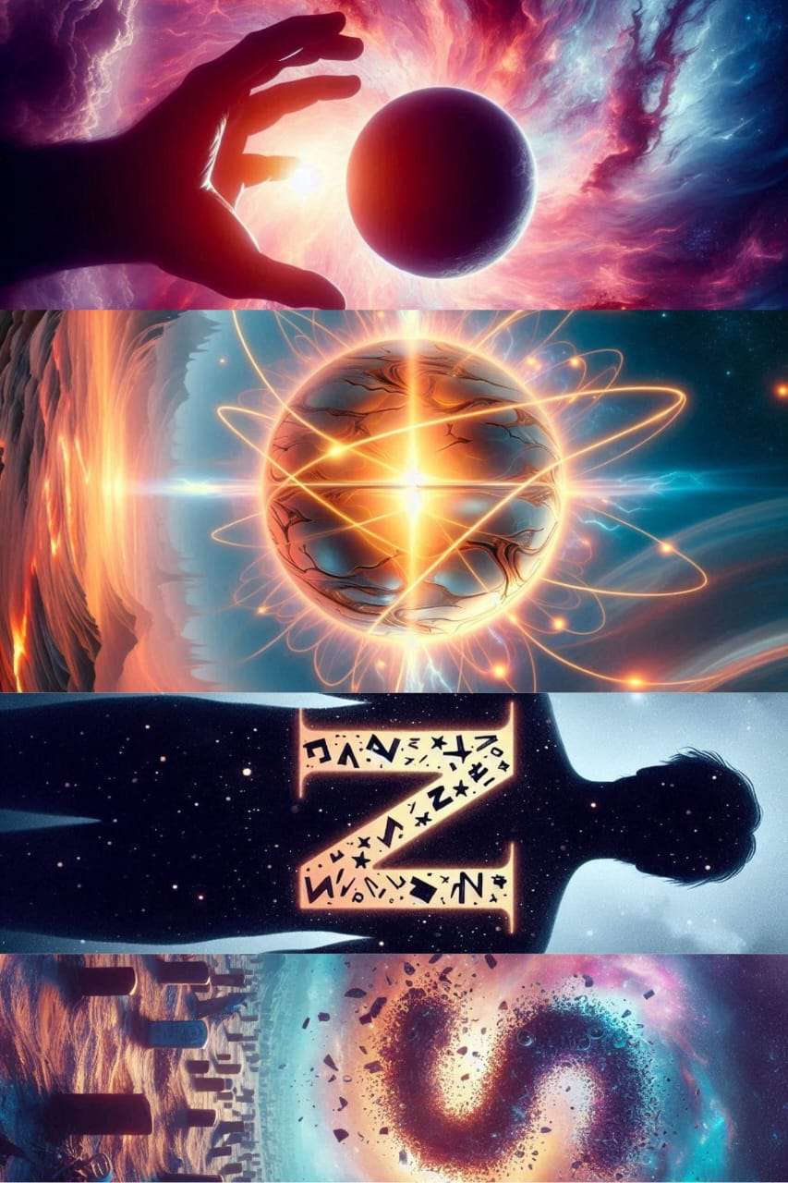

Ai tools used: CHATGPT and COPILOT